FACILITY RENTAL GUIDELINES
2026

INTRODUCTION
The Herbert Hoover Presidential Library and Museum is operated by the National Archives and Records Administration. The Hoover Museum welcomes the use of its facilities by civic groups, businesses, and other organizations for meetings and special events. The Museum’s primary purpose for renting its facilities is to provide the community with greater exposure to its civic and educational value; rentals also generate revenue to support museum programs. Due to the nature of the institution, activities must be appropriate for a museum setting.

GENERAL INFORMATION
General information about facility rentals may be obtained by contacting the Gift Shop Manager at 319-259-8331. All reservations for facility rentals must be confirmed, and the appropriate forms completed in advance.

GUIDELINES
Events must be cultural, recreational, corporate, and/or educational in nature. Personal or commercial events must be approved by the Museum Director. Partisan political activities are not permitted. No implications can be made through written material or media relations that the Hoover Museum is sponsoring the event or has endorsed the organization sponsoring the event. Sales promotions and/or services are prohibited.

SPACE AVAILABILITY
Museum Main Lobby and Olberg Multipurpose Room: These spaces can be used for receptions/events. Capacity varies by use and configuration; an event with 30 to 75 people could comfortably use this space depending upon configuration. This space is available after 5:00 p.m. upon request.
Figge Auditorium: The auditorium seats 175 people. The auditorium is equipped with adjustable stage lighting and a modern podium style lectern with microphone and various presentation input options. It can accommodate symposiums, educational presentations, cultural events, award ceremonies, and various performances.
Olberg Multipurpose Room: This multi-purpose area is ideal for educational use, seminars, and small conferences or luncheons. Depending upon the configuration or use of tables and chairs, the capacity ranges from 20 to 40 people. The room measures 681 square feet. Includes a large media screen with various user input options.

Private Museum Rental: The entire museum, including the Main Lobby, Olberg Room, Figge Auditorium, and optional private tours are available upon request. A maximum of 200 people and 30-day notice is required. This full-access rental includes showings of the Hoover documentary film, use of the Figge Auditorium, and access to exhibits at no additional charge. The gift shop will be available from 9:00 a.m. to 5:00 p.m.
Space Reservations: General availability for all spaces is Monday through Sunday, 9:00 a.m. to 9:00 p.m. All rental space is subject to availability. Contact the Museum Gift Shop Manager for scheduling information, rental fee structure, or to review the application process at 319-259-8331 or hoover.library@nara.gov. Reservations should be made as far in advance as possible.
FEE SCHEDULE
The fees listed below are for the use of the Museum. Fees apply to non-profit as well as for-profit groups.
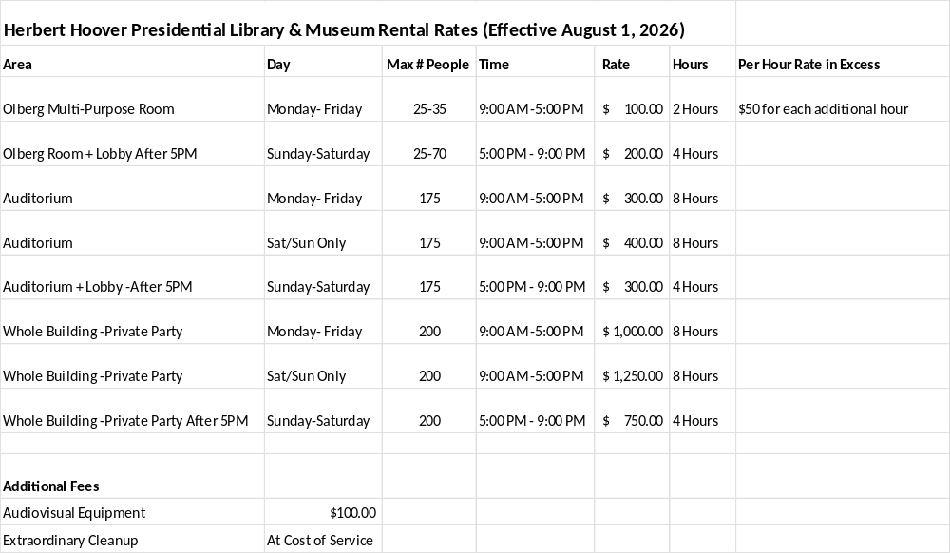

In addition to the building use fee, each guest will be charged the cost of admission to visit the museum. This does not apply to entire private museum rentals.
Group Adult Rates of $10.00 per person may apply with certain rentals.
Admissions Prices: Adults (16-61) $12.00, Seniors (62+), Active/Retired Military (with ID), College Students (with ID) $10.00, Children (6-15) $5.00, Children (5 and under) Free, Hoover Presidential Foundation Members are Free.
Pending availability, special tour arrangements may be made for groups of 15 or more.
For use at no extra charge:
Tables: 22 each 60" X 30”
Folding chairs: 30 with blue color cushions
Stackable chairs: 25 each, wine color cushions
Detailed set-up plans, including decorating details, must be discussed with the staff at the Hoover Museum at least seven days prior to the scheduled function.
Please note that staff members are not available to load and unload equipment or to assist with decorating. Each group is responsible for table set up and take-down under Hoover staff supervision. Areas must be left in a clean and orderly condition following an event to avoid extraordinary cleanup charges. Any rental equipment must be removed the same day. Delivery times are negotiable between the hours of 9 a.m. to 5 p.m. Sponsoring groups must have a representative present to receive and direct setting up of the event.
ADDITIONAL FEES
Additional fees may be charged for the following:
Extraordinary Cleanup – At Cost
Audiovisual Equipment $100
FOOD AND BEVERAGE SERVICE
The renter is responsible for all catering arrangements. The renter and/or the caterer must contact the Museum Gift Shop Manager to coordinate set up, logistics, and limitations in advance of any activities.

ALCOHOLIC BEVERAGES
The Herbert Hoover Museum requires the form na-16011 filled out in advance for approval if alcohol will be on-site during the event.

ADDITIONAL INFORMATION
The Museum is a unique location for facility rentals. To protect and preserve the collections of the museum, please note that food or drink is not allowed in the museum galleries.

The Hoover Museum prohibits the use of flash photography, lighted candles, and the use of all tobacco, vaping, or nicotine products inside the facility.
The Hoover Museum assumes no responsibility or liability for loss, damage, or injury to the renter and/or the renter’s guests or personal property while using the Museum’s facilities.
PARKING
Parking is available in the lot directly outside the museum. Additional parking is available at the National Park Service Visitor Center and the Water Street parking lots. Please do not park along the roadways.

AUDIOVISUAL EQUIPMENT includes but not limited to:
Microphone and podium
Handheld cordless microphones
Wireless microphones
Projector, Sound system, and stage in Figge Auditorium
Wi-Fi
**Laptops or other presentation source devices are not provided by the Hoover Museum.

All equipment is subject to availability. All audiovisual equipment requirements must be arranged at the time of the rental agreement.
For planners or event coordinators who are not familiar with the Hoover Presidential Library and Museum facility, a site visit in advance of rental arrangements is strongly recommended.

The Herbert Hoover Presidential Library and Museum is one of 15 presidential libraries operated by the National Archives and Records Administration.
The Library and Museum is located at 210 Parkside Drive, West Branch, Iowa, 52358, on the grounds of the Herbert Hoover National Historic Site.
The Hoover Library and Museum is located 1/4 mile north of I-80 at Exit 254, in West Branch, Iowa—10 miles east of Iowa City and 50 miles west of the Quad Cities.
The nearest airports are the Eastern Iowa Airport in Cedar Rapids (about 30 miles north-west of West Branch) and the Quad City International Airport in Moline, Illinois (about 60 miles east of West Branch).
For detailed visitor information, you may wish to visit the West Branch website or the Iowa City/Coralville Area Convention and Visitors Bureau . These websites include information about accommodations, dining, and area attractions.

MAP OF RENTAL AREAS 